The Food Pyramid Final Project!

In your child’s science class, we’ve been learning about the importance of eating balanced meals, including a good breakfast. You can help your child understand that foods should be selected daily from the major food groups to create balanced meals.

What You Do:
Help your child use the food pyramid below to plan a healthful meal plan for a breakfast, lunch, and dinner. Which food groups are included in which meals? If possible, invite your child to help you prepare one of the meals that he or she planned. Then, have your child draw a picture of the breakfast, lunch, and dinner he or she planned. Help your child label each part of the meals with the name of the food and which food group it belongs in.

In conclusion:
- Create three meals (breakfast, lunch, and dinner) that are balanced (using as many different food groups in each meal as possible, but definitely using all the food groups at least once)
- Draw the foods in each meal on three separate sheets of paper (included) and have your child label the food and which food group that food is in.
- If possible, create one of the meals your child planned.

What Happened?
Talk with your child about the activity. Help your child understand that a balanced meal consists of foods from different food groups, with not too many fats and sweets (oils). Please have your child return the drawings of each meal to class.

Note: Your child will be presenting his or her project to the class, so please be sure that your child takes ownership of the project and that the project is turned in on time! Feel free to allow your child to be as creative as possible. Thank you!

Due: Thursday, October 4

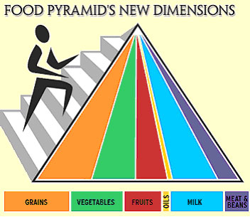

Name: ___________________________

My Balanced Breakfast!

Name: ___________________________

My Balanced Lunch!

Name: ___________________________

My Balanced Dinner!

